How to run multiple containers from a single image, with a single command?
How to run multiple containers from a multiple image, with a single command?
solution: docker compose
How to run multiple containers from a single/multiple images, in to multiple VMs with a single command?
solution: container orchestration
- docker swarm
- kubernetes
How to run multiple containers from a given image?
Why we need more than one container for a single application? HA
We look for an automation tool
docker-compose tool (Single Node) helps to deploy multiple containers from single/multiple images with a single command.
We also need to write a script and call that as docker-compose file.
We write the compose file with extension yaml
service: group of containers from a single image only.
docker stack: group of services
docker-compose tool:
- helps to deploy multiple containers but on a single vm only.
- Dynamic nature of the container with port keeps changing is not possible.
- Is not right tool for production deployment, this can be used only for dev use cases.

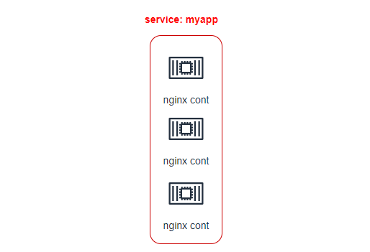

How do execute /run docker-compose file in a single node
Using docker-compose utility we can run docker-compose file
We must install docker-compose utility on your VM.
step1: Install docker-compose utility (help us to run docker-compose file)
sudo curl -L https://github.com/docker/compose/releases/download/1.23.2/docker-compose-`uname -s`-`uname -m` -o /usr/local/bin/docker-compose
sudo chmod +x /usr/local/bin/docker-compose
docker-compose -v
step2: docker-compose means we are talking about multiple container (service)
service: group of containers from a single image.
step3: we can write multiple services in a single-compose file.

docker service create --name myapp --replicas=5 -p 9080:80 nginx:latest
docker service create --name pyapp --replicas=5 -p 9081:3000 lerndevops/samplepyapp:v1
docker service ps <service name> # spread across cluster
docker ps # container running on specific node
docker service rm <service name>
How to write docker-compose file?
nano docker-compose.yaml
services:
myapp: # this is the service name can be anything
image: nginx:latest
ports: # publish the port
- 80 # -P option
# - 9080:80 # -p option
volumes:
# - src(external storage path):target(container path)
- /root/nginxlogs:/var/log/nginx
- / root/nginxconf:/usr/share/nginx/html
docker-compose -f docker-compose.yml up -d # this would create 1 cont.
docker-compose -f docker-compose.yml up --scale <servicename>=5 -d
docker-compose -f docker-compose.yml down
In docker-compose file we write service: group of containers from single image. We can write multiple services in a single docker-compose file.
nano docker-compose.yaml

version: using docker-compose client can talks to the docker-engine
services: It not a single container, group of containers from a single image are
called service (web).
web: name of the service
image: image used by service
ports: image run on which port (Array)
volume: volume-mount
docker-compose up -d # up bring up the containers

docker-compose up --scale web=4 --scale app=6 -d
docker container ls # docker ps
It’s a vertical scaling happening on the single VM.
docker-compose down
Customized file name?
How docker-compose file identified docker-compose. yaml?
docker-compose utility by default tries to read docker-compose. yaml, if we give some other name (mycompose. yaml) in that case, we have to provide the full path.
docker-compose up --file mycompose. yaml --scale web=2 --scale app=3 -d
docker-compose up --file mycompose. yaml down
Stack:
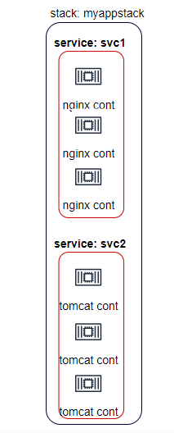
version: "3.7"
services:
svc1: # service name / can be any name of your choice
image: nginx:latest
ports:
- "80" # -P
# - "9080:80" # -p
deploy:
replicas: 4
svc2: # service name / can be any name of your choice
image: tomcat:8.5.40
ports:
- "8080" # -P
deploy:
replicas: 4
docker stack deploy -c compose.yaml myappstack
Limitation:
- It brings up the container in the single node only (SPF), can’t achieve HA.
- Not suitable for production environment.
compose utility is creating multiple containers in the same node, what happens if my node goes down? We are creating multiple containers for HA, but what will happen if my node goes down? Will I get the HA? No, its SPF. It’s helpful in development but not recommended for production environment.
It just provides feature of replicas and scaling up and scaling down.
Solution: Container Orchestration tool
difference between Dockerfile and docker-compose?
dockerfile creates images.
docker-compose file creates containers from a given image.

